The Schrödinger equation and it’s use in defining the orbital shape of hydrogen
Ivan Bakhturin
Introduction and history
From as early as Ancient Greece, people have been curious to find the the true composition of the world around them. What does it really consist of? How fine are the particles that we are made of? The Ancient Greeks called those particles átomos (ἄτομος), meaning “indivisible” or “uncuttable”. We now know these particles as atoms.
Due to the lack of technological advancements, that is as far as people could get when discussing the composition of the world around them, until the early 19th century when the first conjectures were made by scientists, followed by a myriad of proposed models of the atom in the early 20th century. One of the first models was J.J.Thompson’s plum pudding model, followed by Rutherford’s nuclear model of an atom, which was then succeeded by Bohr, who produced the perfect version of the model. However, certain discoveries were made about the atom and electrons, that seemed to contradict not only Bohr’s model, but also the rules of classical physics. Everyone knew that a new type of physics should be created, and the man responsible for playing a fundamental role in creating what we now call quantum physics is Erwin Schrödinger.
Schrödinger realised that Bohr’s model was inaccurate due to three main reasons:
- It relied on fixed orbits rather than probabilistic electron distributions.
- It could not explain more complex atomic structures than hydrogen or finer details of spectra.
- It is impossible to use the equations of classical physics to describe the motion of electrons in an atom, as the wave behaviour of the electron should be taken into the account.
Thus, this led to Schrödinger developing wave mechanics, which is a mathematical technique that describes the relationship between the motion of a particle that shows wave-like properties and its allowed energies. To this day, Schrödinger’s theory successfully describes the energies and spatial distributions of electron in atoms and molecules, but to get a better understanding, let us dive in into the components of the theory and how it is able to create the model of a hydrogen-like atom.
Schrödinger theory and wave functions
Schrödinger formed an equation, which makes use of a mathematical concept called (wave functions). A wave function(Ψ) is a mathematical function that relates the location of an electron at a given point in space to the amplitude of its wave, which corresponds to its energy.
In mathematics wave functions depend on both time and position, however, for atoms wave functions correspond to the arrangement of the electrons, which, if left alone, remain unchanged and are therefore only functions of position. However, how would we visualise these functions? What parameters do they take? A time-independent wave function uses three parameters to describe the position of an electron. It makes use of three coordinates that specify the positions in space. These coordinates are spherical coordinates: r (radial distance), θ (polar angle), φ (azimuthal angle). Apart from that, wave functions also have both real and imaginary parts, making them complex functions.
To visualise wavefunctions numerically, we can use Python to generate electron probability clouds. For example, the hydrogen 1s orbital, for which we would be solving the Schrödinger equation later.

The code: 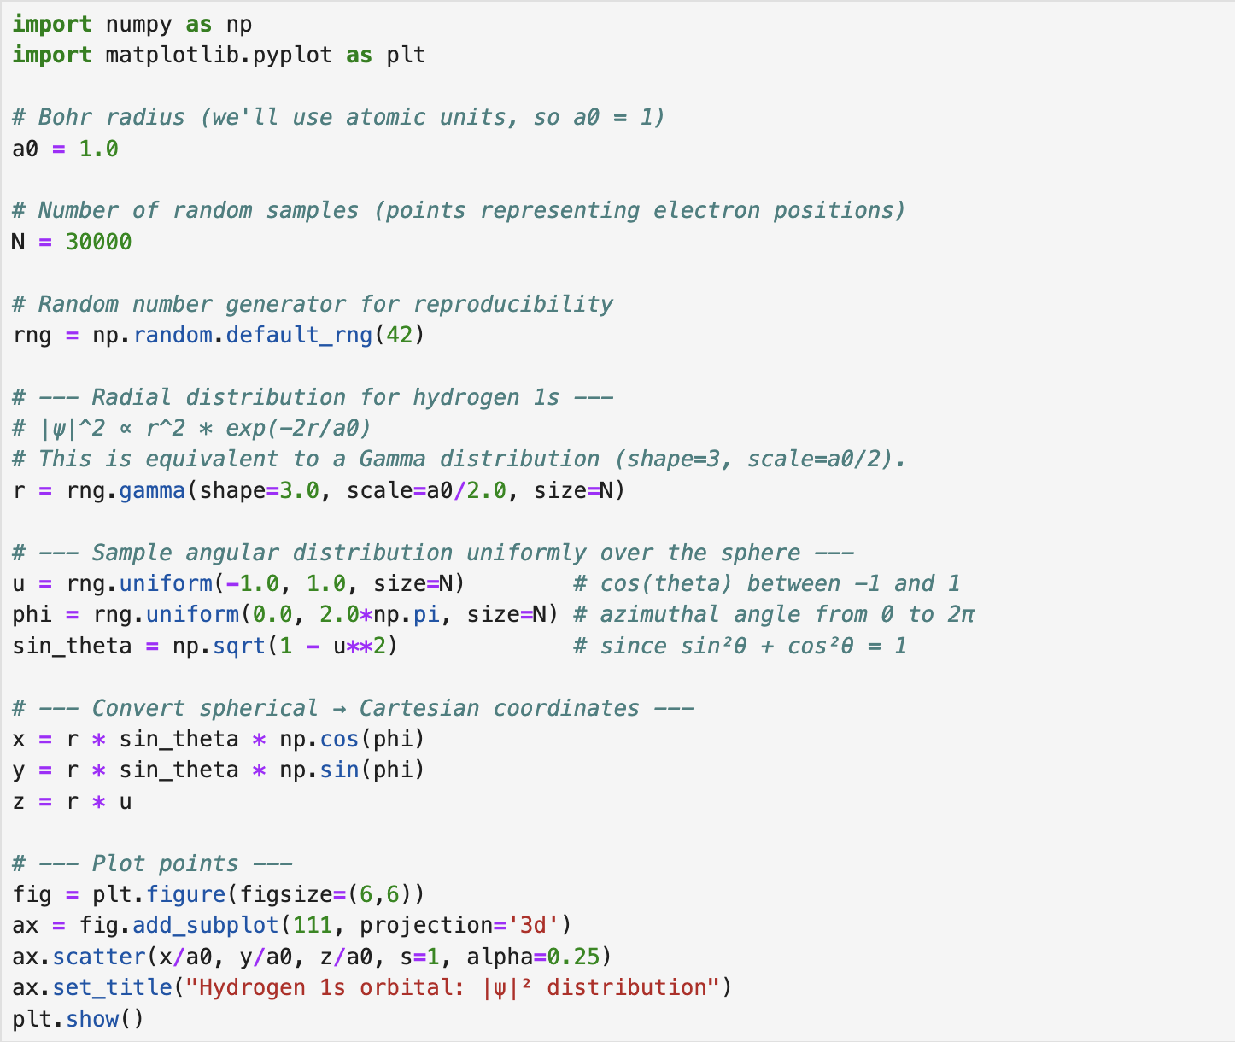
The output:
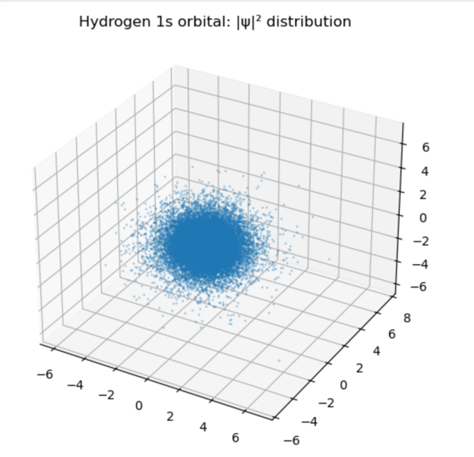
The parameters change uncontrollably, and we would never really know the coordinates, unless we observe the electron or estimate probabilities. The probability of finding an electron at a point is given by the product of the wave function Ψ and its complex conjugate Ψ*. The product is called the modulus square and for wave functions it always must be a real positive number or zero (at the nodes).
So, what makes each wave function unique and how does the probability depend on the types of wave functions? It is the unique set of quantum numbers, which determine the wave function and affect the probability of finding an electron. The probability also depends on the spherical coordinates. The three main rules of calculating probability are:
- The total probability of finding the electron anywhere must be 100%.
- Each wave function has a unique set of quantum numbers.
- Each wave function is associated with a particular energy.
Quantum Numbers
So, what are the so important quantum numbers? Schrödinger’s approach requires three quantum numbers to specify a wave function: the principal quantum number(n), the azimuthal quantum number(l), and the magnetic quantum number(m_{l}).
- The principal quantum number:
Tells the average relative distance of an electron from the nucleus and indicates the energy of the electron.
- The azimuthal quantum number:
Describes the shape of the region of space occupied by an electron. The allowed values of l depend on the value of n and can range from 0 to n-1.
- The magnetic quantum number:
Describes the orientation of the region of space occupied by an electron with respect to an applied magnetic field. The allowed values of m_{l} depend on the value of l: m_{l} can range from -l to l in integral steps.

We can use Python to generate all allowed quantum numbers for a given n
The code and the output: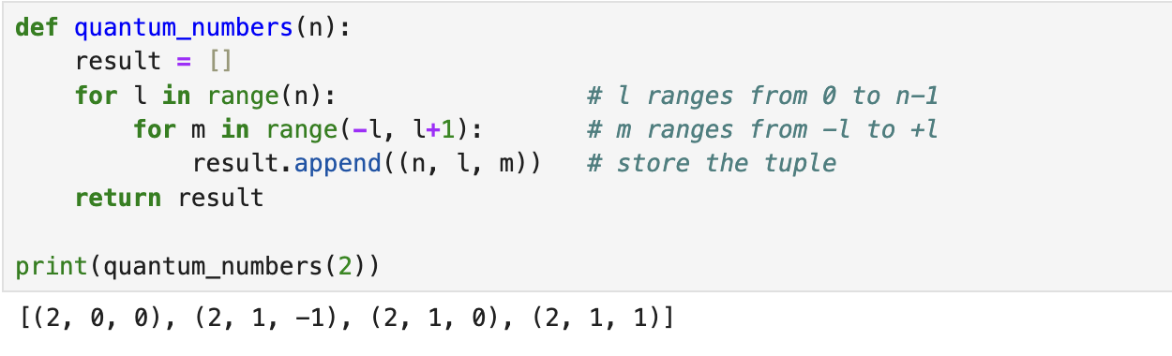
Orbital shapes
The combination of all these parameters affects the probability of finding an electron, which then creates a specific shape of an orbital. Orbitals are mathematically derived regions of space with different probabilities of having an electron. Generally, we look at a region where electron is supposed to be 90% of the time.
The probability of finding an electron in a region of space with a volume V is the product of the volume with Ψ Ψ* (|Ψ|^2). Having calculated the probability, we are then able to create a visual image by plotting a graph of |Ψ|^2 against the distance from the nucleus, which would create probability density. We can also calculate radial probability by adding together the probabilities of an electron being at all points on a series of x spherical shells of radius r1;r2;r3…;rx-1;rx, essentially integrating the orbital and adding up all the probabilities.
The electron probability density is greatest at r = 0, so the density of dots is greatest for the smallest spherical shapes. Due to rapidly increasing surface area, as r increases, the probability density decreases. As important, when r is very small, the surface area of a spherical shell is so small that the total probability of finding an electron close to the nucleus is very low; at the nucleus, the electron probability vanishes because surface ares of the shell is 0.
Spherical harmonics can be used to numerically plot these shapes in Python:
The code:
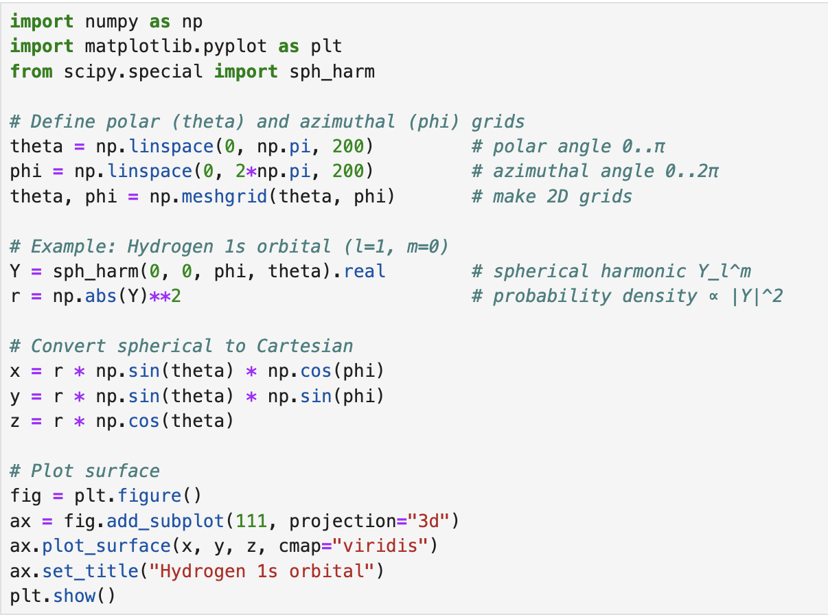
The output:

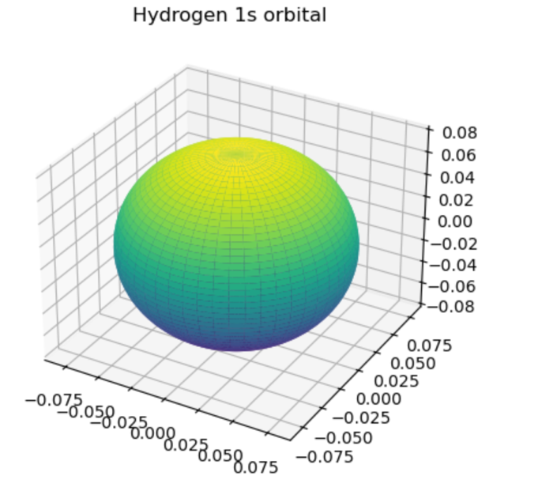
For the hydrogen atom, the peak in the radial probability plot occurs at r = 0.529Å(53.9pm), which is the radius calculated by Bohr for the n = 1 orbit. Thus, the most probable radius obtained from quantum mechanics is identical to the radius calculated by classical mechanics. Now, let us solve the Schrödinger equation to find the shape of the hydrogen atom.
The components of the Schrödinger equation
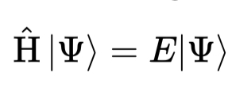
The Schrödinger equation consists of the following:
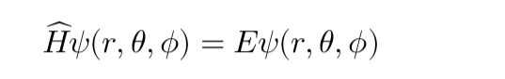
where H is a Hamiltonian operator, psi is a wavefunction and E is the total energy of a system. The time-independent equation can also be represented in spherical coordinates:

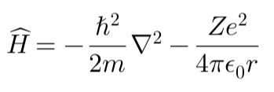
The Hamiltonian is expressed as:
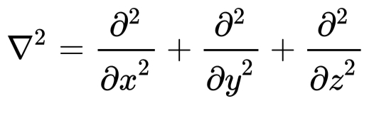
Where:
Is a Laplacian operator in 3D

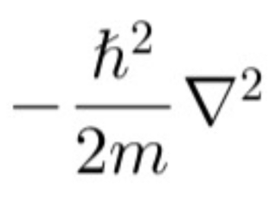
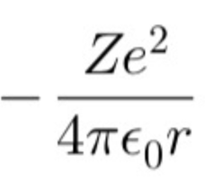
Is the kinetic energy of the electron
Is a Coulomb potential for an electron in a nucleus with the charge Z
Solving the equation for hydrogen
For hydrogen(Z=1), we aim to solve the function.
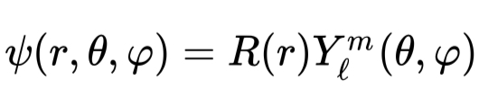
We assume that the wavefunction can be written as:
Where:
- R(r) is the radial part of the wavefunction, dependent on r, representing an orbital and its distance from the nucleus, on which electron is found.
- Y(theta, psi) is the angular part of the wavefunction, dependent on angles theta and psi, representing the spherical harmonics of electron motion. However, since hydrogen atim(1s, where l=0) is spherically symmetric, Y(theta, psi) = 1/sqrt(4pi), meaning that the wavefunction only depends on the radial part.
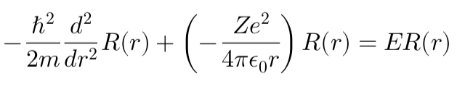
Now we can substitute everything we know into the equation above:

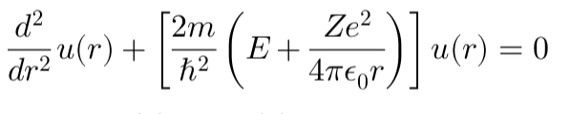
Schrödinger radial equation:
Where u(r) = rR(r)
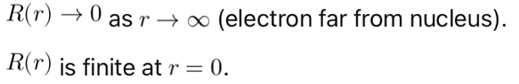
We can solve this by applying boundary conditions:

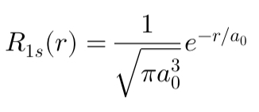
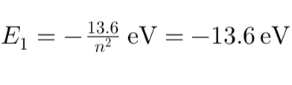
For n=1, l=0(1s orbital):
- Radial wavefunction:
- Energy:

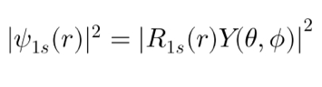
Probability density is given by |Ψ|^2:
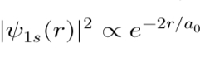
However, since Y(theta, psi) is a constant:
As a result, this equation produces a spherical shape with the highest probability density near the nucleus.
We can model and plot this shape with Python using heatmaps and radial distribution:
Radial probability:
Code:
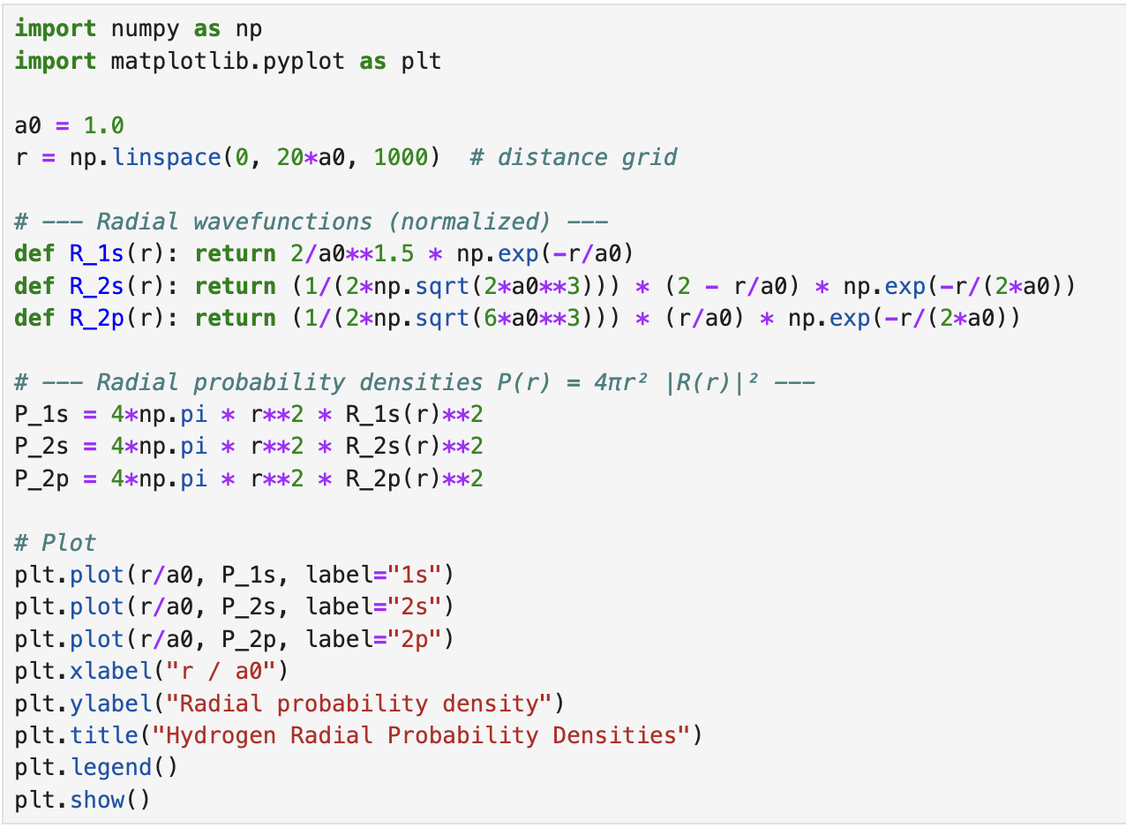

Output:
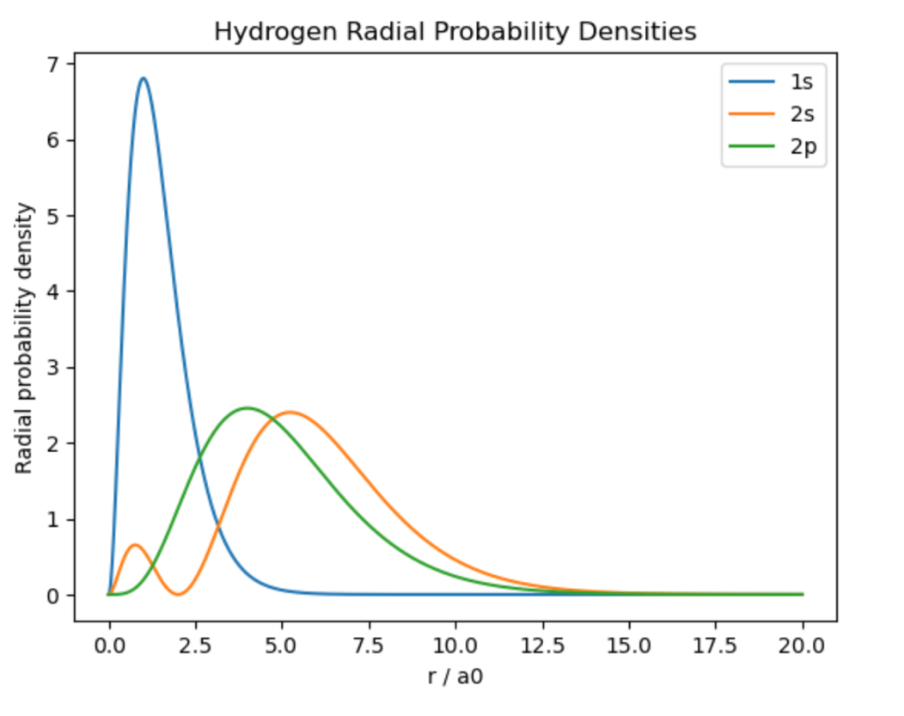
This graph shows that the highest probability density in hydrogen orbitals at a distance of r = 0.529Å(53.9pm) from the nucleus, which is more commonly known as Bohr radius.
Heatmaps:
Code:
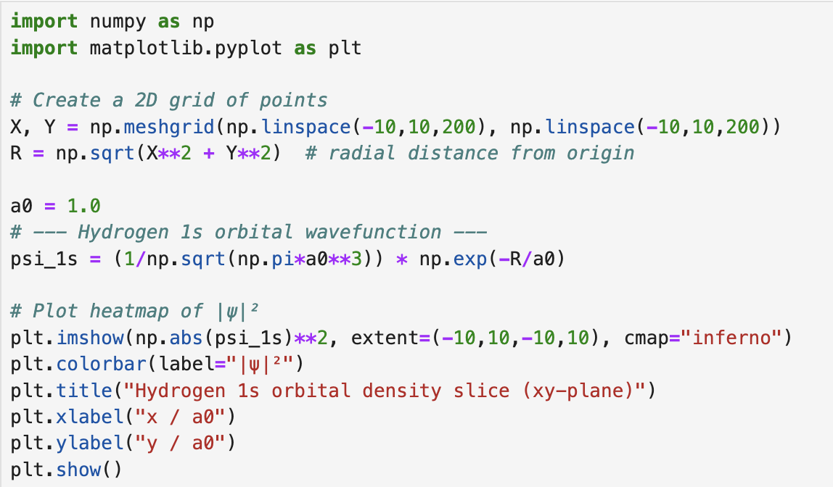

Output:
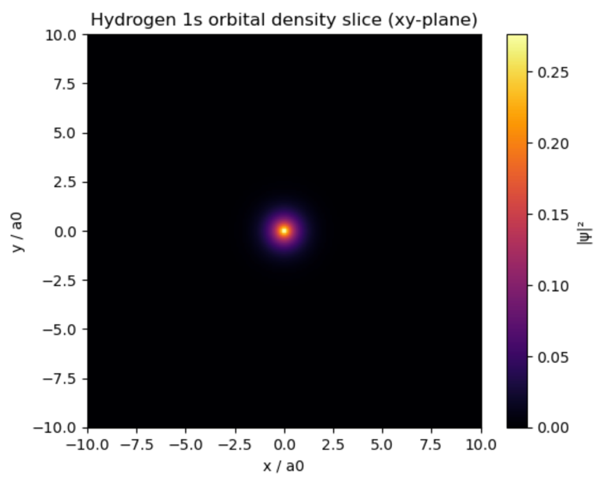
Conclusion
The Schrödinger equation changed the way that we conceptualize atoms, from rigid orbits to wavefunctions and probability. Although hydrogen may be solved exactly, most cannot, and thus numerical optimisation is required. By programming in Python to represent orbitals, plot probability densities and execute the variational method, I was able to appreciate how programming takes abstract equations and turns them into concrete graphical output. This demonstrates the power of combining theory and computation: mathematics builds the scaffolding, and coding and numerical methods allow us to explore quantum systems far beyond what is feasible by hand.

Sources and references:
https://chem.libretexts.org/Courses/Howard_University/General_Chemistry%3A_An_Atoms_First_Approach/Unit_1%3A__Atomic_Structure/Chapter_2%3A_Atomic_Structure/Chapter_2.5%3A_Atomic_Orbitals_and_Their_Energies#av_1.0-ch02_s05_s03_f01
https://en.wikipedia.org/wiki/Azimuthal_quantum_number
https://www.khanacademy.org/science/chemistry/atomic-structure-and-properties/orbitals-and-electrons/a/the-quantum-mechanical-model-of-the-atom
https://youtu.be/U2dy_9SQ3No?si=Hh3OV3EShIJ3IwNY
https://youtu.be/-Y0XL-K0jy0?si=G2kD2d4gln43CL41
https://youtu.be/acN7E7AUHPk?si=z6hEd9du5rw-v0xN
https://en.wikipedia.org/wiki/Hamiltonian_(quantum_mechanics)
https://en.wikipedia.org/wiki/Laplace_operator
https://en.wikipedia.org/wiki/Spherical_harmonics
https://en.wikipedia.org/wiki/Spherical_coordinate_system
https://www.home.cern/news/news/physics/atomic-flashback-century-bohr-model#:~:text=However%2C%20the%20model%20was%20misleading,electron%20is%20likely%20to%20be
https://docs.scipy.org/
https://matplotlib.org/stable/tutorials/index.html
https://numpy.org/doc/stable/
https://docs.scipy.org/doc/scipy/
https://quantum-book.readthedocs.io/
https://scipython.com/blog/visualizing-hydrogen-atom-orbitals/

